Hassan Ahmed Hamza Shabbir

Abstract

Quantum computers are the future, and a lot of work is being done to realize a practical quantum computer. Cryogenic chips are a big step in the right direction but there are still many obstacles to overcome.

CEP

Integrated Electronics

**Quantum Computing:**

Use of quantum mechanics to perform computations in a new and improved way to give us an exponential gain in compute performance over what is available today. The basic building block of quantum computer is qubit. So, unlike a zero or one state the qubit exists in a superposition of zero or one sate giving us endless possibilities and probabilities in the state of a qubit.

**Qubits**

A single qubit can be represented by an electron which can move between two energy states i.e., the high energy level and low energy level. The electron at each energy level can be represented by a spin. Electron at lower energy level is represented by spin down notation and electron at higher energy level is represented by spin up notation. An electron in spin down state can be provided by a specific amount of energy using electromagnetic wave microwave in most cases of specific frequency to move it in the spin up state. So, the difference come between normal bits and qubits. Because of superposition theorem we can say that given a specific amount of energy the qubit can be found in neither of the two states rather in between them. This ability of the qubit to be in kind of two states at the same time gives quantum computers their power to compute exponential problems very quickly.

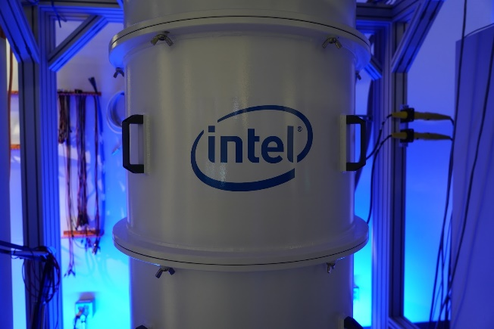

**Silicon based qubits:**

There are two good reasons to build quantum bits out of silicon. The first one is the more obvious one that is the level of advancement the silicon-based microelectronics. Although there are many challenges in the way but the speed at which these advancements are made it is inevitable that silicon-based electronics will be involved in making of quantum computers.

The second reason is not that obvious as discussed earlier while operating with qubits we are measuring the spin of a single electron. So, we need to create an environment with a type of material with no spin and fortunately for us 95.3% of the naturally occurring isotopes of silicon (Si28 and Si30) have zero spin.

So now how the silicon-based qubits work? Most commonly an atom of phosphorous is added as an impurity in the silicon whose electrons are used as qubits in the same way as discussed earlier. So, what happens is that with the help of external field the electron of phosphorous is made stay in the spin down condition, then an electromagnetic wave whose properties depend on the material and the magnetic field it is placed in, is used to give the electron enough energy to move up in the spin up condition. The outer circuitry is made in such a way that when the electron comes in the spin up position it produces an excess current which is measured to find out that the electron is now in spin up position. Taking if further a step we can use the nucleus of phosphorous atom to control the position of its electron. Since the spin in which the electron is in also depends on the spin of the nucleus which can also be changes with the help of a specific electromagnetic wave, we can control the nucleus of a single atom.

**Problem:**

The problem is that at room temperature the electrons of phosphorous have enough energy that they vibrate between the spin up and spin down condition so to control the spin the temperature must be reduced close to absolute zero so as to remove all the thermal energy from the electron which is also possible but the electronics part which will make use of the qubits does not work at that low temperature so there is a separation between the qubits and the operating system which makes it difficult to control enough qubits to make a difference.

A second major problem is encountered that as the qubits are very susceptible to noise. Even the slightest change in temperature can provide so much energy to qubits so they will continuously be in a spin up or spin down state and the circuit will be useless.

Another problem is that the qubits work in superposition i.e., we cannot measure exactly whether the qubit is in spin up or spin down, so we have to work with probabilities. The concept is like Schrodinger’s cat or Heisenberg uncertainty principle in quantum mechanics. So, in order to design quantum algorithms and make our circuit work we need to write the same information to multiple qubits. In this way we increase the probability of the information written to qubits but as a result we need more and more no of qubits.

**Cryogenic Chips:**

Cryogenic chips are chips used in Quantum computers. These chips are formed with the traditional silicon wafer fabrication technology but has phosphorous atoms inside it so that it can be controlled by placing them inside external magnetic field. They can be moved from spin up or spin down by placing them between two electrodes which provide the magnetic field. Now previously each qubit required that a wire be used to provide the appropriate microwave signal for it to switch in two states. Qubits operate at close to 1 kelvin temperature and so as the no of qubits increase it is very difficult to provide a wire for each qubit for providing the microwave signal. The new technology introduced that the control circuit and the silicon-based qubits are fabricated on a single silicon wafer. This allows us to greatly increase the no of qubits and increase the computational power exponentially.

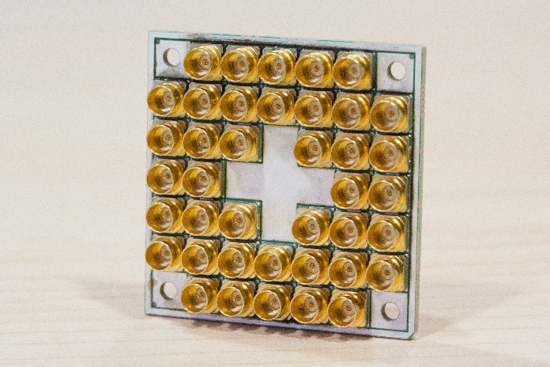

**CryoCMOS**

The above chip is called Horse Ridge designed by intel by modifying its CMOS technology. Horse Ridge translates quantum-computer instructions into basic qubit operations, which it delivers to the processor as microwave signals.

Horse Ridge is designed to work at 4 kelvins a slightly higher temperature than the qubit chip itself, but low enough to sit inside the refrigerator with it. Intel used its 22-nanometer FinFET manufacturing process to build the chip, but the transistors that make up the control circuitry needed substantial reengineering.

**Limitations of cryogenic chips:**

The qubits which we are using these days are operating at about 0.001K and on the other hand the cryogenic chip has a working temperature of 4K, so there still is a small bridge which is needed to overcome before we can have some practical quantum computers. For a quantum computer to solve some useful problems and give some valuable results we need to operate millions of qubits together. Moreover, the cryogenic chips are very sensitive to temperature any increase in temperature can hinder the operation of the chips so the temperature around the cryogenic chip needs to be maintained very closely.

**Possible solutions:**

We need to develop new qubits which can operate at higher temperature for example 1K or 2K and more research on cryogenic chips can also result in lowering of their operating temperatures. Multiple connections of these chips in series and parallel combinations may result in manipulation of many more qubits together.

By using nanotechnology, we can build nanoscale electronic and photonic devices with new quantum functionality. Those devices are measured at very low temperatures (close to absolute zero temperature). By using high-tech nanofabrication, low-temperature setups, and low-noise electronics we can turn quantum mechanics into a new resource for technology.

Figure 1 An InSb nanowire connected to source and drain contacts and capacitively coupled to 5 narrow gate electrodes.

An approach toward building a topological quantum computer is to combine one-dimensional nanowires with large spin-orbit coupling and conventional superconductors. In the presence of a magnetic field the ends of these wires are expected to host Majorana zero modes (MZMs). Since the first signatures of MZMs were observed in nanowires in 2012, there has been remarkable progress in the field, whereby the very existence of MZMs has been put on much stronger footing.

The next important step toward realizing a topological quantum computer is to scale these systems up. The past few years have seen remarkable progress on the theoretical front leading up to concrete, experimentally viable proposals for creating topological qubits. Each of these approaches employs different schemes to encode the qubit and to perform topologically protected braiding operations. However, they all share a common requirement: the ability to engineer a large number of well-ordered topological regions integrated with auxiliary elements to manipulate and read out the state of the qubit.

A solution is to use wafer scale III-V semiconductor two-dimensional electron gases (2DEGs) to bring together all the necessary ingredients for topological quantum computing onto a single, scalable 2D platform. The inherent flexibility offered by a 2D architecture will allow us to study different protocols for the generation and detection of MZMs.

**High-Temperature operating Silicon Qubits:**

The qubits explained earlier using silicon were operating at very close to zero kelvin temperature, which as we showed is not ideal foe quantum computers. On the other hand leaving silicon behind can also not be considered an option because of such advancement in this field. So we purpose a solution were we address a single deep impurity, having strong electron confinement of up to 0.3 eV, using single-electron tunneling transport. This way we can achieve qubits operation at 5-10K through a spin-blockade effect based on the tunneling transport via two impurities. The deep impurity will be implemented by tunnel field-effect transistor (TFETs) instead of conventional FETs. With further improvements we can expect qubit operation at higher temperature.